S.NO | SOFA SET
  NAME OF ITEM | TOTAL FABRIC REQ. | PRICE WITHOUT FABRIC
  NAME OF ITEM | 07-SEATER/Mtr  Simple + Print | 1 SEATER | 2 SEATER | 3 SEATER | 7 SEATER
1 | 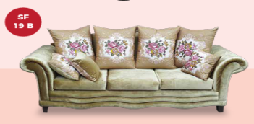  SF-19 B SOFA SET (3+2+1+1) WITH CUSHION |  | 22+15 |  | 400  Length: 100  Width: 85  Height: 45 | 800  Length: 160  Width: 85  Height: 45 | 1200  Length: 210  Width: 85  Height: 45 | 2800
2 | 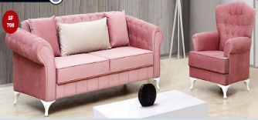  SF-708 SOFA SET (3+2+1+1) WITH CUSHION |  | 40 |  | 571 | 1145 | 1713 | 4000
3 | 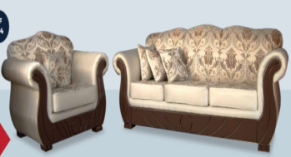  SF- 304 SOFA SET (3+2+1+1) WITH CUSHION |  | 24+14 |  | 407 | 814 | 1221 | 2850
4 | 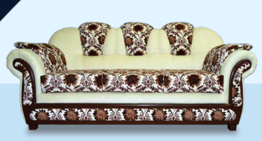  SF-320 SOFA SET (3+2+1+1) WITH CUSHION |  | 33+9 |  | 357 | 715 | 1071 | 2500
5 | 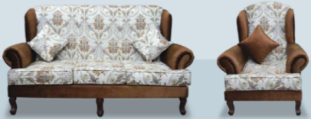  SF-051 SOFA SET (3+2+1+1) WITH CUSHION |  | 22+15 |  | 329 | 658 | 986 | 2300
6 | 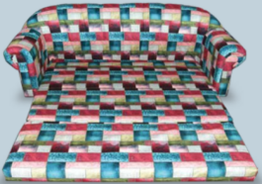  SF-109 TOKRI SCB 1 Piece 3-Seater |  | 12 |  |  |  |  | 1000
7 | 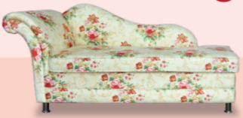  SF-110 LOVE CHAIR 1 PIECE |  | 12 |  |  |  |  | 1500
8 | 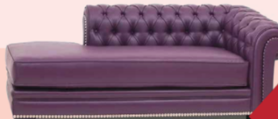  SF-730 LOVE CHAIR 1 PIECE |  | 14 |  |  |  |  | 1800
9 | 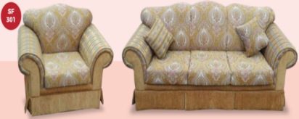  SF-301  SOFASET (3+2+1+1)  WITH CUSHION |  | 25+15 |  | 314 | 628 | 942 | 2200
10 | 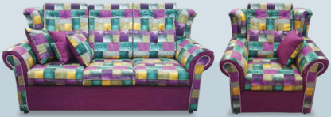  SF-313 SOFA SET (3+2+1+1) WITH CUSHION |  | 15+19 |  | 258 | 514 | 771 | 1800
11 | 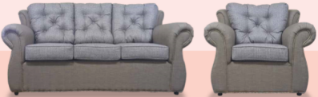  SF-315 SOFA SET (3+2+1+1) WITH CUSHION |  | 22+15 |  | 230 | 457 | 685 | 1600
12 | 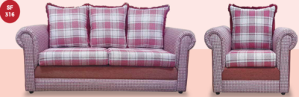  SF-316 SOFA SET (3+2+1+1) WITH CUSHION |  | 13+20 |  | 228 | 456 | 684 | 1200
13 | 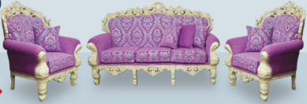  SF-319 SOFA SET (3+2+1+1) WITH CUSHION |  | 18+10 |  | 857 | 1715 | 2571 | 6000
14 | 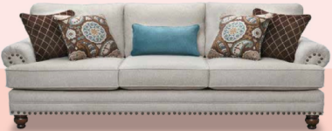  SF-697 SOFA SET (3+2+1+1) WITH CUSHION |  | 35+3 |  | 500 | 1000 | 1500 | 3500
15 | 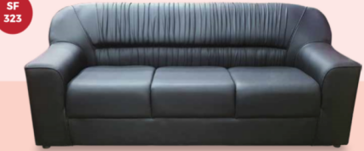  SF-323 SOFA SET PVC (3+2+1+1) WITH CUSHION |  | 22 |  | 300 | 600 | 900 | 2100
16 | 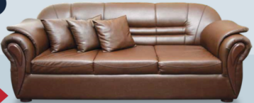  SF-325 SOFA SET PVC (3+2+1+1) WITH CUSHION |  | 35 |  | 430 | 856 | 1284 | 3000
17 | 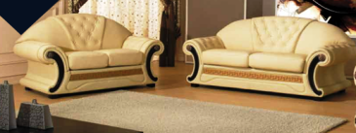  SF-698 SOFA SET PVC (3+2+1+1) WITH CUSHION |  | 42 |  | 257 | 515 | 771 | 1800
18 | 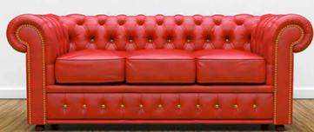  SF-699 SOFA SET (3+2+1+1) WITH CUSHION |  | 42 |  | 500 | 1000 | 1500 | 3500
19 | 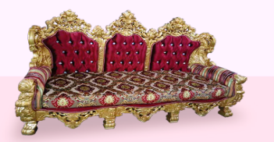  SF-700 SOFA SET (3+2+1+1) WITH CUSHION |  | 40 |  | 1429 | 2857 | 4285 | 10000
20 | 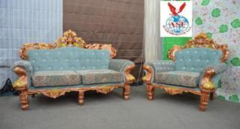  SF-701 SOFA SET (3+2+1+1) WITH CUSHION |  | 38 |  | 857 | 1715 | 2571 | 6000
21 | 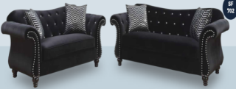  SF-702 SOFA SET (3+2+1+1) WITH CUSHION |  | 38 |  | 457 | 915 | 1371 | 3200
22 | 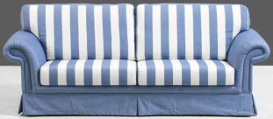  SF-703 SOFA SET (3+2+1+1) WITH CUSHION |  | 20+25 |  | 314 | 628 | 942 | 2200
23 | 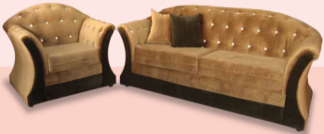  SF-704 SOFA SET (3+2+1+1) WITH CUSHION |  | 38 |  | 314 | 628 | 942 | 2200
24 | 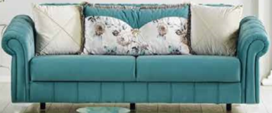  SF-705 SOFA SET (3+2+1+1) WITH CUSHION |  | 45 |  | 500 | 1000 | 1500 | 3500
25 | 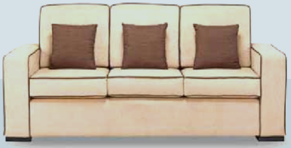  SF-706 SOFA SET (3+2+1+1) WITH CUSHION |  | 43 |  | 400 | 800 | 1200 | 2800
26 | 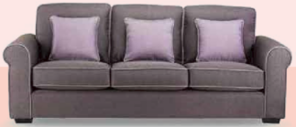  SF-707 SOFA SET (3+2+1+1) WITH CUSHION |  | 43 |  | 285 | 575 | 855 | 2000
27 | 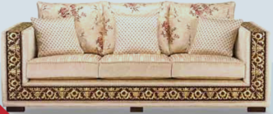  SF-709 SOFA SET (3+2+1+1) WITH CUSHION |  | 42 |  | 457 | 915 | 1371 | 3200
28 | 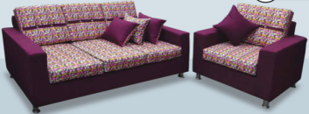  SF-710 SOFA SET (3+2+1+1) WITH CUSHION |  | 22+18 |  | 285 | 575 | 855 | 2000
29 | 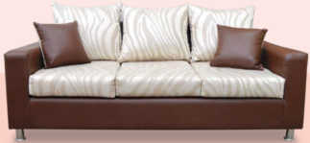  SF-711 SOFA SET (3+2+1+1) WITH CUSHION |  | 3+2+1+1 |  | 357 | 715 | 1071 | 2500
30 | 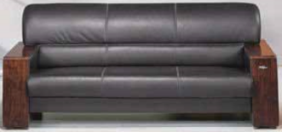  SF-712 SOFA SET (3+2+1+1) WITH CUSHION |  | 3+2+1+1 |  | 500 | 1000 | 1500 | 3500
31 | 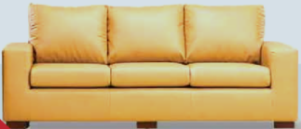  SF-713 SOFA SET (3+2+1+1) WITH CUSHION |  | 3+2+1+1 |  | 400 | 800 | 1200 | 2800
32 | 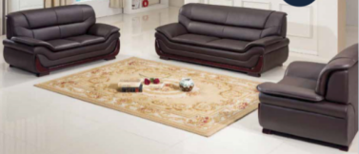  SF-714 SOFA SET (3+2+1+1) WITH CUSHION |  | 35 |  | 414 | 830 | 1242 | 2900
33 | 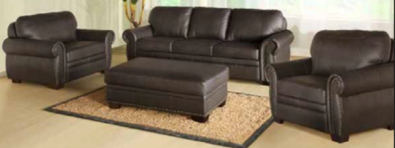  SF-715 SOFA SET (3+2+1+1) |  | 42 |  | 285 | 575 | 855 | 2000
34 | 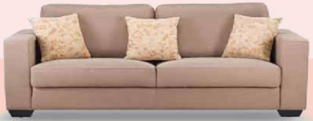  SF-716 SOFA SET (3+2+1+1) WITH CUSHION |  | 42 |  | 357 | 715 | 1071 | 2500
35 | 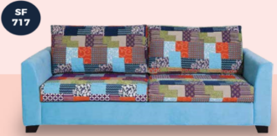  SF-717 SOFA SET (3+2+1+1) WITH CUSHION |  | 42 |  | 400 | 800 | 1200 | 2800
36 | 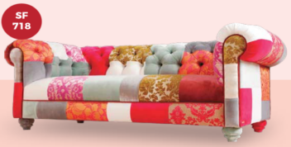  SF-718 SOFA SET (3+2+1+1) WITH CUSHION |  | 40 |  | 642 | 1290 | 1926 | 4500
37 | 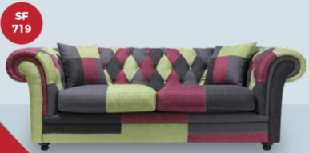  SF-719 SOFA SET (3+2+1+1) WITH CUSHION |  | 40 |  | 357 | 715 | 1071 | 2500
38 | 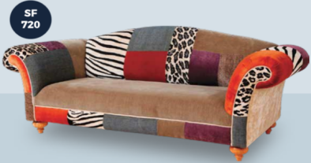  SF-720 SOFA SET (3+2+1+1) WITH CUSHION |  | 40 |  | 457 | 915 | 1371 | 3200
39 | 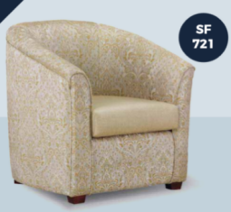  SF-721 SOFA SET SINGLE WITH CUSHION |  | 1 |  |  |  |  | 800
40 | 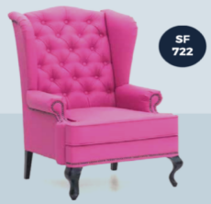  SF-722 SOFA SET SINGLE WITH CUSHION |  | 1 |  |  |  |  | 1300
41 | 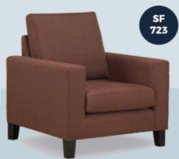  SF-723 SOFA SET SINGLE WITH CUSHION |  | 1 |  |  |  |  | 600
42 | 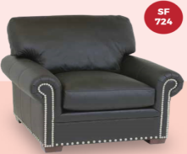  SF-724 SOFA SET SINGLE WITH  CUSHION |  | 1 |  |  |  |  | 600
43 | 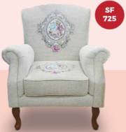  SF-725 SOFA SET SINGLE WITH  CUSHION |  | 1 pc |  |  |  |  | 1000
44 | 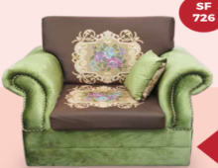  SF-726 SOFA SET SINGLE WITH  CUSHION |  | 1 pc |  |  |  |  | 1000
45 | 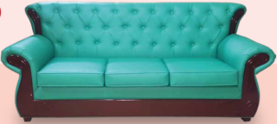  SF-727 SOFA SET (3+2+1+1) WITH CUSHION |  | 38 |  | 400 | 800 | 1200 | 2800
46 | 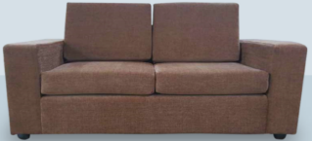  SF-728 SOFA SET (3+2+1+1) WITH CUSHION |  | 42 |  | 285 | 575 | 855 | 2000
47 | 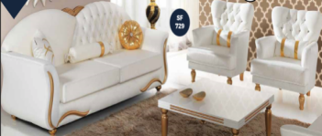  SF-729 SOFA SET (3+2+1+1) WITH CUSHION |  | 3+2+1+1 |  | 857 | 1715 | 2571 | 6000
48 | 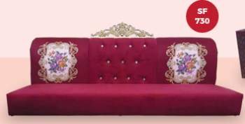  SF-730 MAJLIS (PER METER) |  | 1 |  |  |  |  | 650
49 | 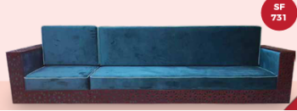  SF-731 MAJLIS (PER METER) |  | 1 |  |  |  |  | 800
50 | 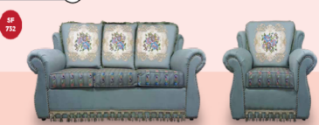  SF-732 SOFA SET (3+2+1+1) |  | 22+15 |  | 285 | 575 | 855 | 2000
51 | 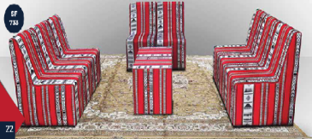  SF-733 MAJLIS (2-SEATER ) |  | 1 |  |  |  |  | 550
 | MAJLIS
1 | 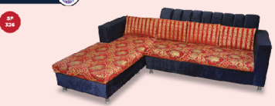  SF-326 MAJLIS (PER METER) |  |  | 1 |  |  |  | 550
2 | 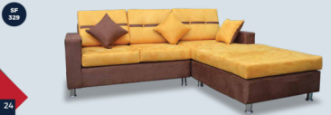  SF-329 MAJLIS (PER METER) |  |  | 1 metr |  |  |  | 800
3 | 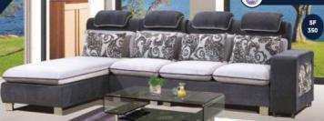  SF-350 MAJLIS (PER METER) |  |  | 1 metr |  |  |  | 800
4 | 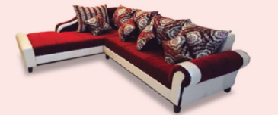  SF-351 MAJLIS (PER METER) |  |  | 1 metr |  |  |  | 800
5 | 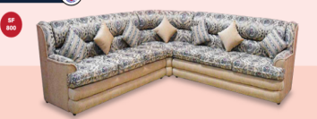  SF-800 MAJLIS (PER METER) |  |  | 1 metr |  |  |  | 700
6 | 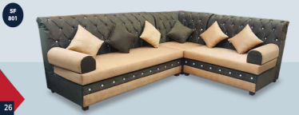  SF-801 MAJLIS (PER METER) |  |  | 1 metr |  |  |  | 800
7 | 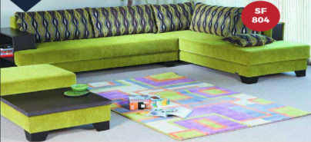  SF-804 MAJLIS (PER METER) |  |  | 1 metr |  |  |  | 600
8 | 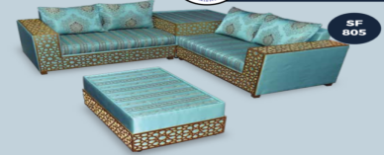  SF-805 MAJLIS (PER METER) |  |  | 1 metr |  |  |  | 1000
9 | 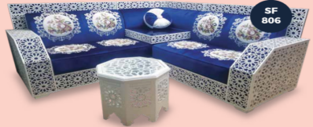  SF-806 MAJLIS (PER METER) |  |  | 1 metr |  |  |  | 1300
10 | 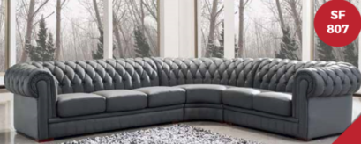  SF-807 MAJLIS (PER METER) |  |  | 1 metr |  |  |  | 1200
11 | 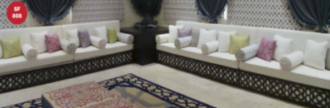  SF-808 MAJLIS (PER METER) |  |  | 1 metr |  |  |  | 750
12 | 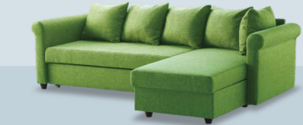  SF-809 MAJLIS (PER METER) |  |  | 1 metr |  |  |  | 650
13 | 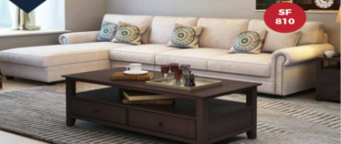  SF-810 MAJLIS (PER METER) |  |  | 1 metr |  |  |  | 800
14 | 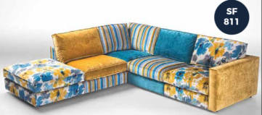  SF-811 MAJLIS (PER METER) |  |  | 1 metr |  |  |  | 800
15 | 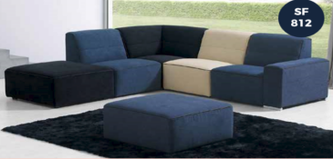  SF-812 MAJLIS (PER METER) |  |  | 1 metr |  |  |  | 600
16 | 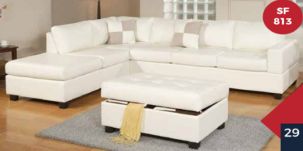  SF-813 MAJLIS (PER METER) |  |  | 1 metr |  |  |  | 600
17 | 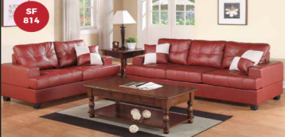  SF-814 MAJLIS (PER METER) |  |  | 1 metr |  |  |  | 1000
18 | 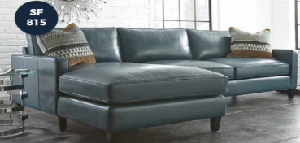  SF-815 MAJLIS (PER METER) |  |  | 1 metr |  |  |  | 1000
19 | 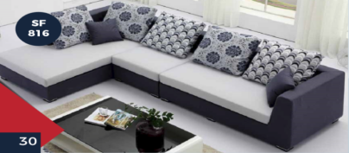  SF-816 MAJLIS (PER METER) |  |  | 1 metr |  |  |  | 600
20 | 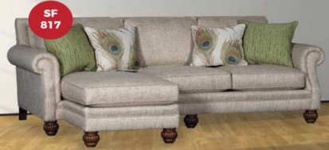  SF-817 MAJLIS (PER METER) |  |  | 1 metr |  |  |  | 700
21 | 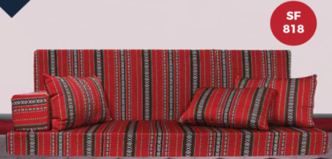  SF-818 FOAM MAJLIS (SEAT+BACK(100*70*12)+(100*55*12)) PER METER |  |  | 1 metr |  |  |  | 650
22 | 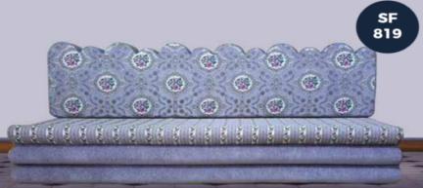  SF-819 FOAM MAJLIS (PER METER) |  |  | 1 metr |  |  |  | 650
23 | 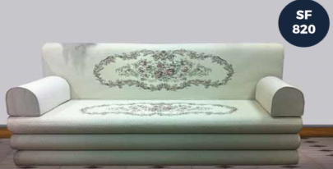  SF-820 FOAM MAJLIS (SEAT+BACK(100*70*30)+(100*55*12) HALF ROUND (20*20*50) PER METER |  |  | 3+2+1+1 | 257 | 515 | 771 | 1800
24 | 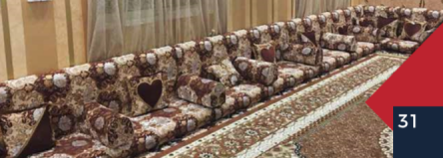  SF-821 FOAM MAJLIS (PER METER) |  |  | 1 metr |  |  |  | 550
25 | 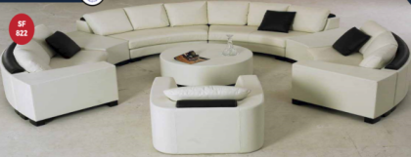  SF-822 MAJLIS (PER METER) |  |  | 1 metr |  |  |  | 950
26 | 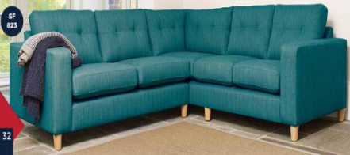  SF-823 MAJLIS (PER METER) |  |  | 1 metr |  |  |  | 750
 | BEDROOMS
1 | 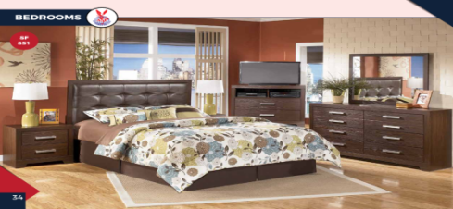  SF-851 BEDROOM (NORMAL) |  |  | 2 SIDE TABLE | 6 DOOR CUPBOARD | TOP PILLOW SPRING MATTRESS | DRESSING TABLE | 6500
2 | 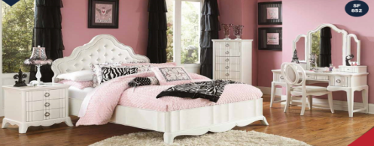  SF-852 BEDROOM (NORMAL) |  |  | 2 SIDE TABLE | 6 DOOR CUPBOARD | TOP PILLOW SPRING MATTRESS | DRESSING TABLE | 12000
3 | 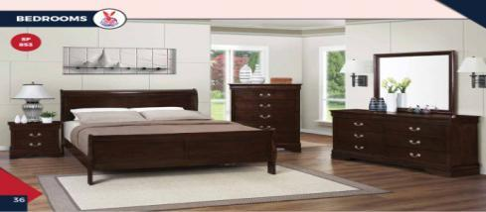  SF-853 BEDROOM (NORMAL) |  |  | 2 SIDE TABLE | 6 DOOR CUPBOARD | TOP PILLOW SPRING MATTRESS | DRESSING TABLE | 6000
4 | 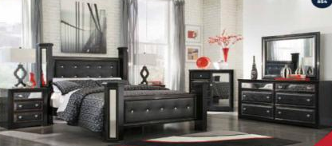  SF-854 BEDROOM (NORMAL) |  |  | 2 SIDE TABLE | 6 DOOR CUPBOARD | TOP PILLOW SPRING MATTRESS | DRESSING TABLE | 6000
5 | 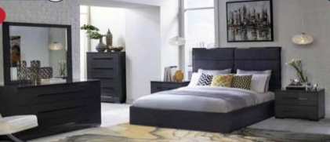  SF-855 BEDROOM (NORMAL) |  |  | 2 SIDE TABLE | 6 DOOR CUPBOARD | TOP PILLOW SPRING MATTRESS | DRESSING TABLE | 7000
6 | 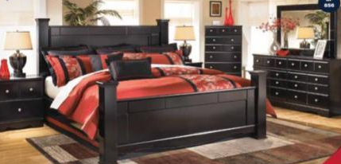  SF-856 BEDROOM (NORMAL) |  |  | 2 SIDE TABLE | 6 DOOR CUPBOARD | TOP PILLOW SPRING MATTRESS | DRESSING TABLE | 8000
7 | 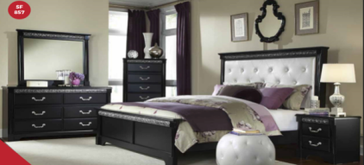  SF-857 BEDROOM (NORMAL) |  |  | 2 SIDE TABLE | 6DOOR CUPBOARD | TOP PILLOW SPRING MATTRESS | DRESSING TABLE | 8000
8 | 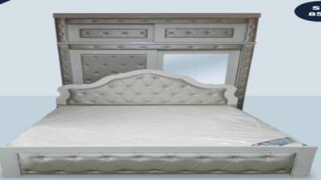  SF-858 BEDROOM (NORMAL) |  |  | 2 SIDE TABLE | 6 DOOR CUPBOARD | TOP PILLOW SPRING MATTRESS | DRESSING TABLE | 5500
9 | 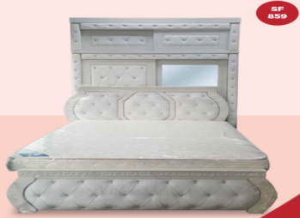  SF-859 BEDROOM (NORMAL) |  |  | 6 DOOR CUPBOARD | 2 SIDE TABLE | TOP PILLOW SPRING MATTRESS | DRESSING TABLE | 5500
10 | 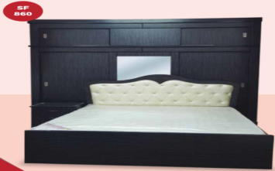  SF-860 BEDROOM (NORMAL) |  |  | 6 DOOR CUPBOARD | 2 SIDE TABLE | TOP PILLOW SPRING MATTRESS | DRESSING TABLE | 7000
11 | 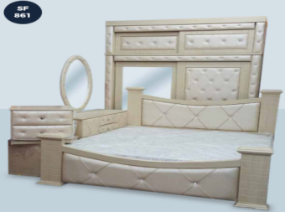  SF-861 BEDROOM (NORMAL) |  |  | 6 DOOR CUPBOARD | 2 SIDE TABLE | TOP PILLOW SPRING MATTRESS | DRESSING TABLE | 7000
DIVAN BED
1 | 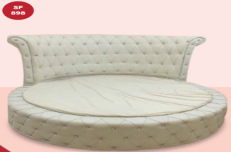  SF-898 BASE+H.B (220*220 CM) |  |  |  |  |  |  | 3500
2 | 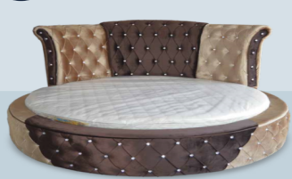  SF-899 BASE+H.B (220*220 CM) |  |  |  |  |  |  | 3500
3 | 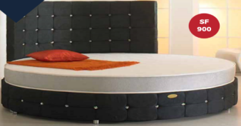  SF-900 BASE+H.B (220*220 CM) |  |  |  |  |  |  | 3500
4 | 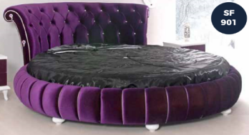  SF-901 BASE+H.B (220*220 CM) |  |  |  |  |  |  | 3500
5 | 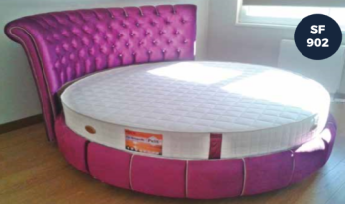  SF-902 BASE+H.B (220*220 CM) |  |  |  |  |  |  | 3500
6 | 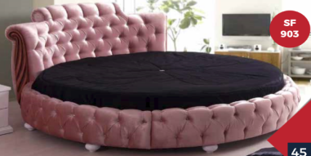  SF-903 BASE+H.B (220*220 CM) |  |  |  |  |  |  | 4500
7 | 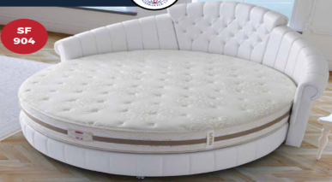  SF-904 BASE+H.B (220*220 CM) |  |  |  |  |  |  | 3500
8 | 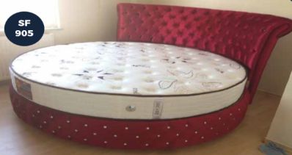  SF-905 BASE+H.B (220*220 CM) |  |  |  |  |  |  | 4500
9 | 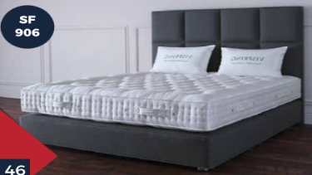  SF-906 BASE+H.B (200*180 CM) |  |  |  |  |  |  | 3200
10 | 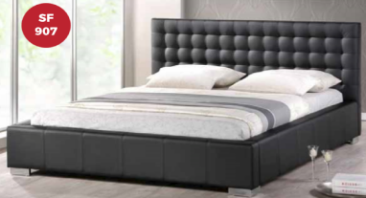  SF-907 BASE+H.B (20*180 CM) |  |  |  |  |  |  | 3200
11 | 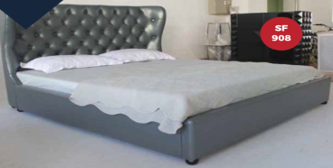  SF-908 BASE+H.B (200*180 CM) |  |  |  |  |  |  | 3200
12 | 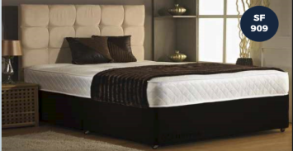  SF-909 BASE+H.B (200*180 CM) |  |  |  |  |  |  | 3200
13 | 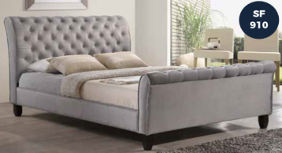  SF-910 BASE+H.B (200*180 CM) |  |  |  |  |  |  | 3200
14 | 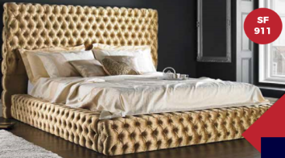  SF-911 BASE+H.B (200*180 CM) |  |  |  |  |  |  | 3200
15 | 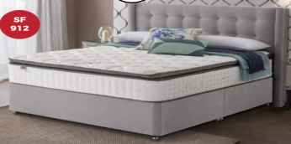  SF-912 BASE+H.B (200*180 CM) |  |  |  |  |  |  | 3200
16 | 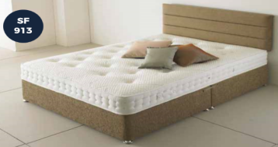  SF-913 BASE+H.B (200*180 CM) |  |  |  |  |  |  | 3200
17 | 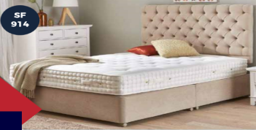  SF-914 BASE+H.B (200*180 CM) |  |  |  |  |  |  | 3500
18 | 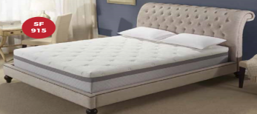  SF-915 BASE+H.B (200*180 CM) |  |  |  |  |  |  | 3500
19 | 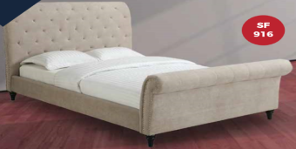  SF-916 BASE+H.B (200*180 CM) |  |  |  |  |  |  | 2500
20 | 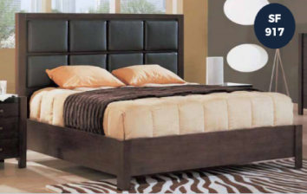  SF-917 BASE+H.B (200*180 CM) |  |  |  |  |  |  | 2500
21 | 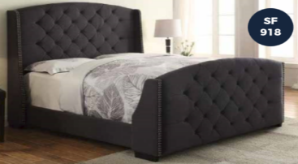  SF-918 BASE+H.B (200*180 CM) |  |  |  |  |  |  | 2500
22 | 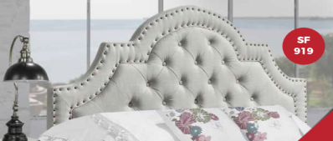  SF-919 BASE+H.B (H.BOARD 180 CM) |  |  |  |  |  |  | 1000
23 | 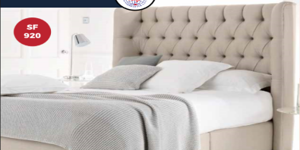  SF-920 BASE+H.B (200*180 CM) |  |  |  |  |  |  | 3200
24 | 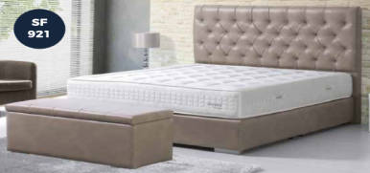  SF-921 BASE+H.B (200*180 CM) |  |  |  |  |  |  | 3200
25 | 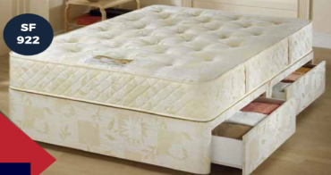  SF-922 BASE (200*180 CM) |  |  |  |  |  |  | 1800
26 | 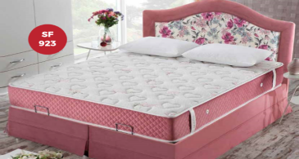  SF-923 BASE+H.B (200*180 CM) |  |  |  |  |  |  | 3200
27 | 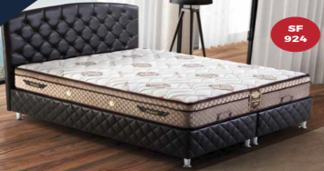  SF-924 BASE+H.B (200*180 CM) |  |  |  |  |  |  | 3200
28 | 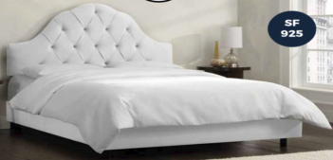  SF-925 BASE+H.B (200*180 CM) |  |  |  |  |  |  | 3200
29 | 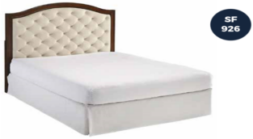  SF-926 BASE+H.B (190*180 CM) |  |  |  |  |  |  | 1800
30 | 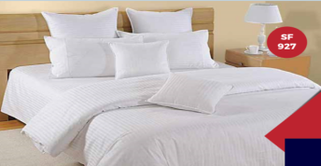  SF-927 KING SIZE (COMFORTER 220*240 CM) |  |  |  |  |  |  | 350
31 | 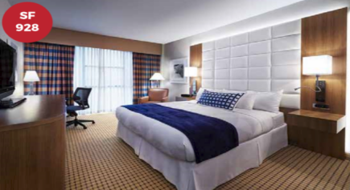  SF-928 BASE+H.B (190*180 CM) |  |  | 2 SIDE TABLE | DRESSING TABLE | TOP PILLOW SPRING MATTRES |  | 7000
32 | 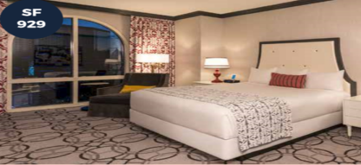  SF-929 BASE+H.B (200*180 CM) |  |  | 2 SIDE TABLE | DRESSING TABLE | TOP PILLOW SPRING MATTRES |  | 3500
33 | 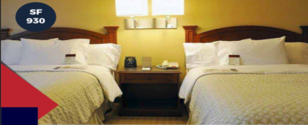  SF-930 BASE+H.B (190*180 CM) |  |  |  |  |  |  | 1800
34 | 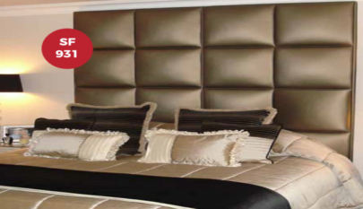  SF-931 HEAD BOARD 180 CM |  |  |  |  |  |  | 1200
35 | 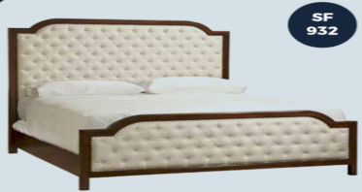  SF-932 BASE+H.B (200*180 CM) |  |  |  |  |  |  | 3800
36 | 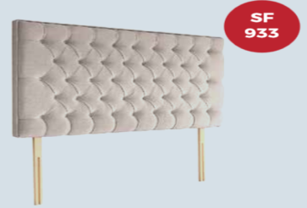  SF-933 HEAD BOARD 200*180*130CM |  |  |  |  |  |  | 1500
37 | 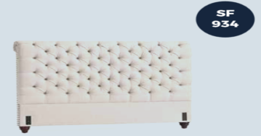  SF-934 HEAD BOARD 200*150CM |  |  |  |  |  |  | 1500
38 | 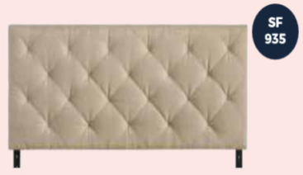  SF-935 HEAD BOARD 200*150CM |  |  |  |  |  |  | 1500
39 | 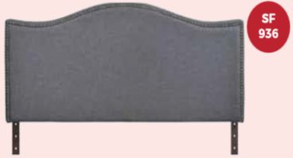  SF-936 HEAD BOARD 200*180CM |  |  |  |  |  |  | 1200
40 | 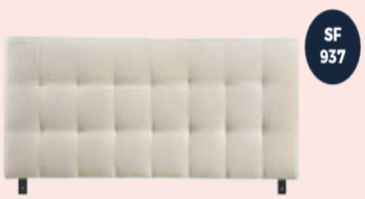  SF-937 HEAD BOARD 200*180CM |  |  |  |  |  |  | 1100
41 | 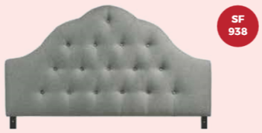  SF-938 HEAD BOARD200*150CM |  |  |  |  |  |  | 1100
42 | 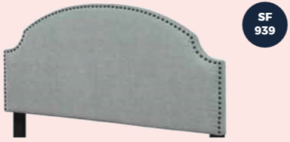  SF-939 HEAD BOARD200*150CM |  |  |  |  |  |  | 1100
43 | 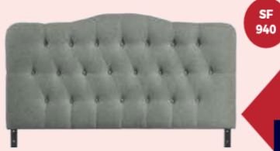  SF-940 HEAD BOARD 200*150CM |  |  |  |  |  |  | 1300
MATTRESS
0 | 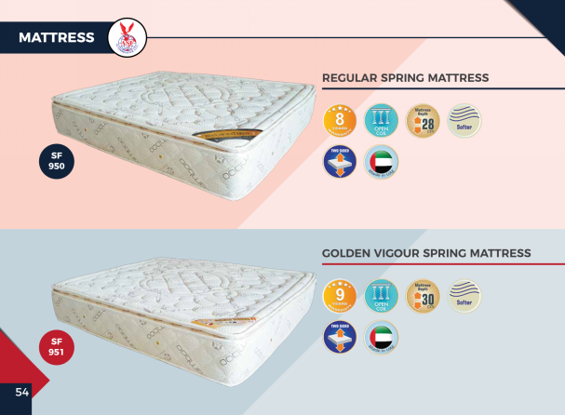 |  |  | 200*180*28 |  |  |  | 1128
1 |  |  |  | 200*180*30 |  |  |  | 1210
2 | 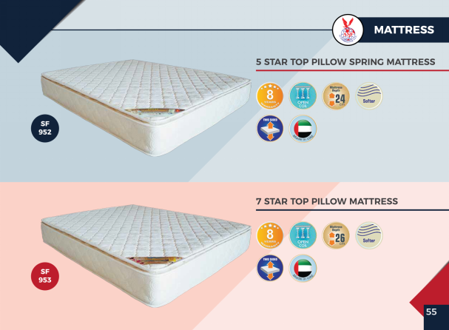 |  |  | 200*180*24 |  |  |  | 907
3 |  |  |  | 200*180*26 |  |  |  | 982
4 | 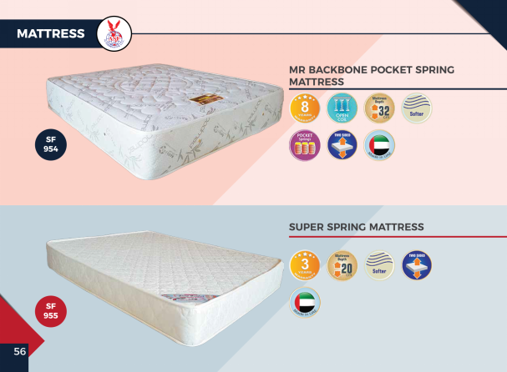 |  |  | 200*180*32 |  |  |  | 1612
5 |  |  |  | 200*180*20 |  |  |  | 756
6 | 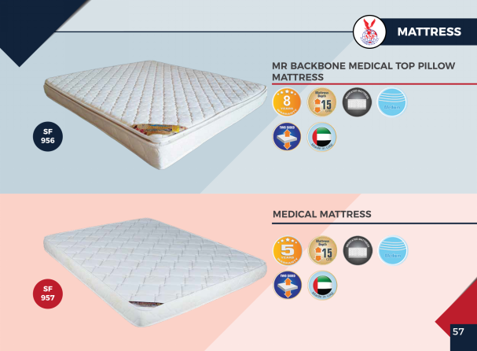 |  |  | 200*180*15 |  |  |  | 495
7 |  |  |  | 200*180*10 |  |  |  | 252

